Lumecca Case Studies

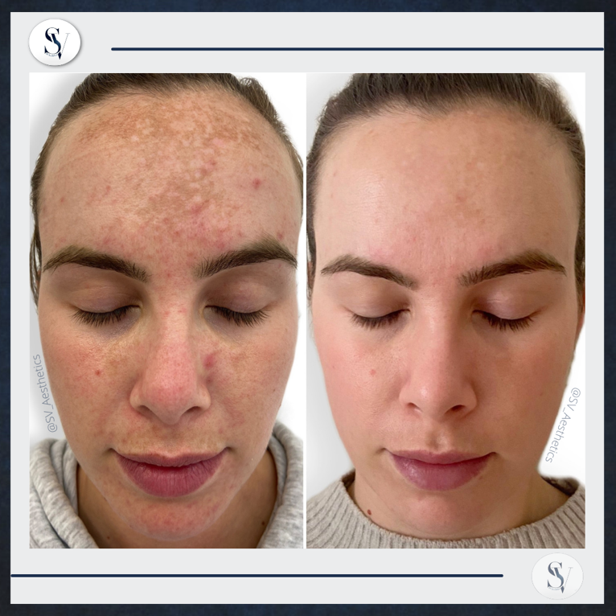 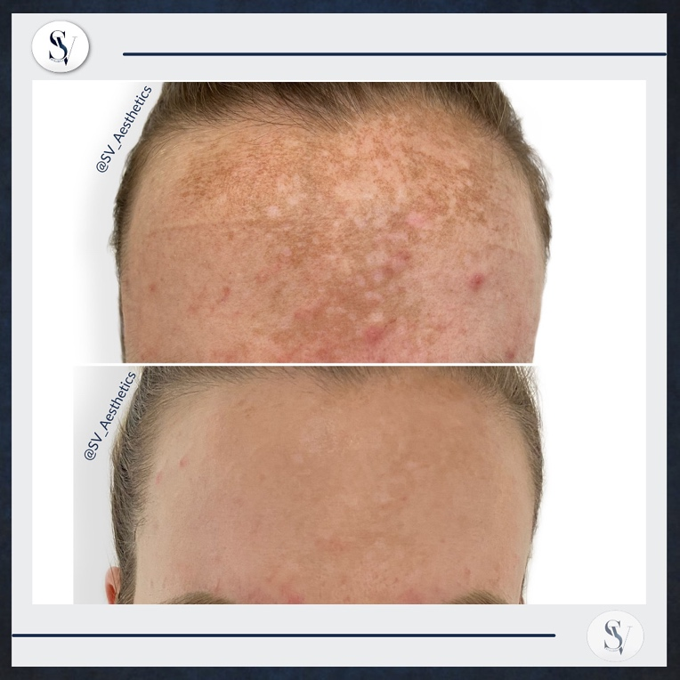

Physician: SV Aesthetics

Procedure: Lumecca IPL 515nm

Number of Sessions: Before & After 3 Sessions on Full Face

Age: Female, 33

Area Treated: Full Face

Energy: 12 J/cm2

Cooling: Strong

Description/More Details:

Female with skin type 2 requested treatment to reduce hyper pigmentation on full face (concentrate on forehead). These are the results after 3 sessions. On each session we did one pass on the entire face & a 2nd lower pass after 15 minutes on a 20% reduced settings – we avoided the forehead on the 2nd pass. Pigments darkened after each session & then became lighter. The patient was extremely happy with the results after 12 weeks.